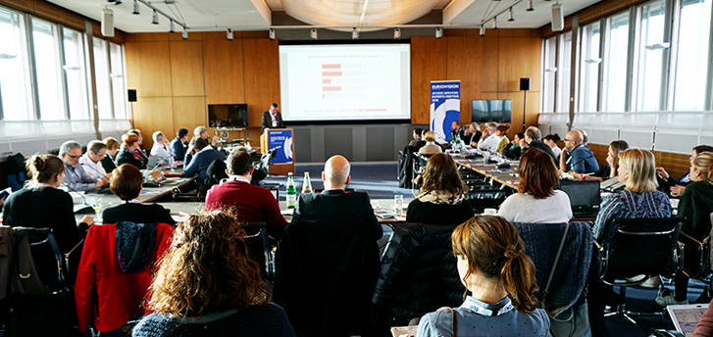
Silica Safety & Competent Person Training  The Occupational Health and Safety Administration has issued a final rule to curb exposure to respirable crystalline silica. If your work involves drilling, cutting, crushing, or grinding silica containing materials such as concrete and stone OR you have employees on sites with these tasks occurring, you need to be aware of the new exposure limits and control methods. With enforcement already underway in Construction and General Industry, come learn from a Certified Industrial Hygienist and your peers on how to best mitigate your silica exposure. The presenter for this session is Mark Wiggins, CIH with Liberty Mutual Insurance – Risk Control Services. This course is designed by The Liberty Mutual Group & McGriff Insurance Services to assist companies in complying with the OSHA regulations Occupational Exposure to Crystalline Silica in Construction. | When:  Thursday, September 26, 2019  12:00 – 4:00pm  Lunch will be served at 12pm.  WHERE:  Roanoke Regional Home Builders Association, Inc.  1626 Apperson Drive  Salem, VA 24153  540-389-7135  Cost:  $45, Includes Lunch  $55, Non Member Pricing w/Lunch  WHO SHOULD ATTEND:  Safety Managers, Human Resource Managers, Project Managers, Superintendents, Construction Workers  REGISTER: https://rrhba.com/event/silica-safety-competent-person-training/
The Risk Solutions Group – 855-228-2377 – www.McGriffinsurance.com
© 2019, McGriff Insurance Services, Inc. All rights reserved.

